**RESULTS**

**6.1 Snapshots of the project and description**



**Fig.5.1 Home page of Storybook Management System**

Fig.5.1 is the home page of the website which shows Home, Display and Admin login options.



**Fig.5.2 Search operation for a storybook**

Fig.5.2 shows the details of the storybook searched and it is found. The details include Book title, Author, Publisher, Year of publish and Genre.



**Fig.5.3 Search operation when record not found**

Fig.5.3 shows the search operation where the entered book title is not found.



**Fig.5.4 Addition of storybooks in Admin side**

Fig.5.4 shows addition operation where admin can add new books by filling all the details of the storybook which is being added.

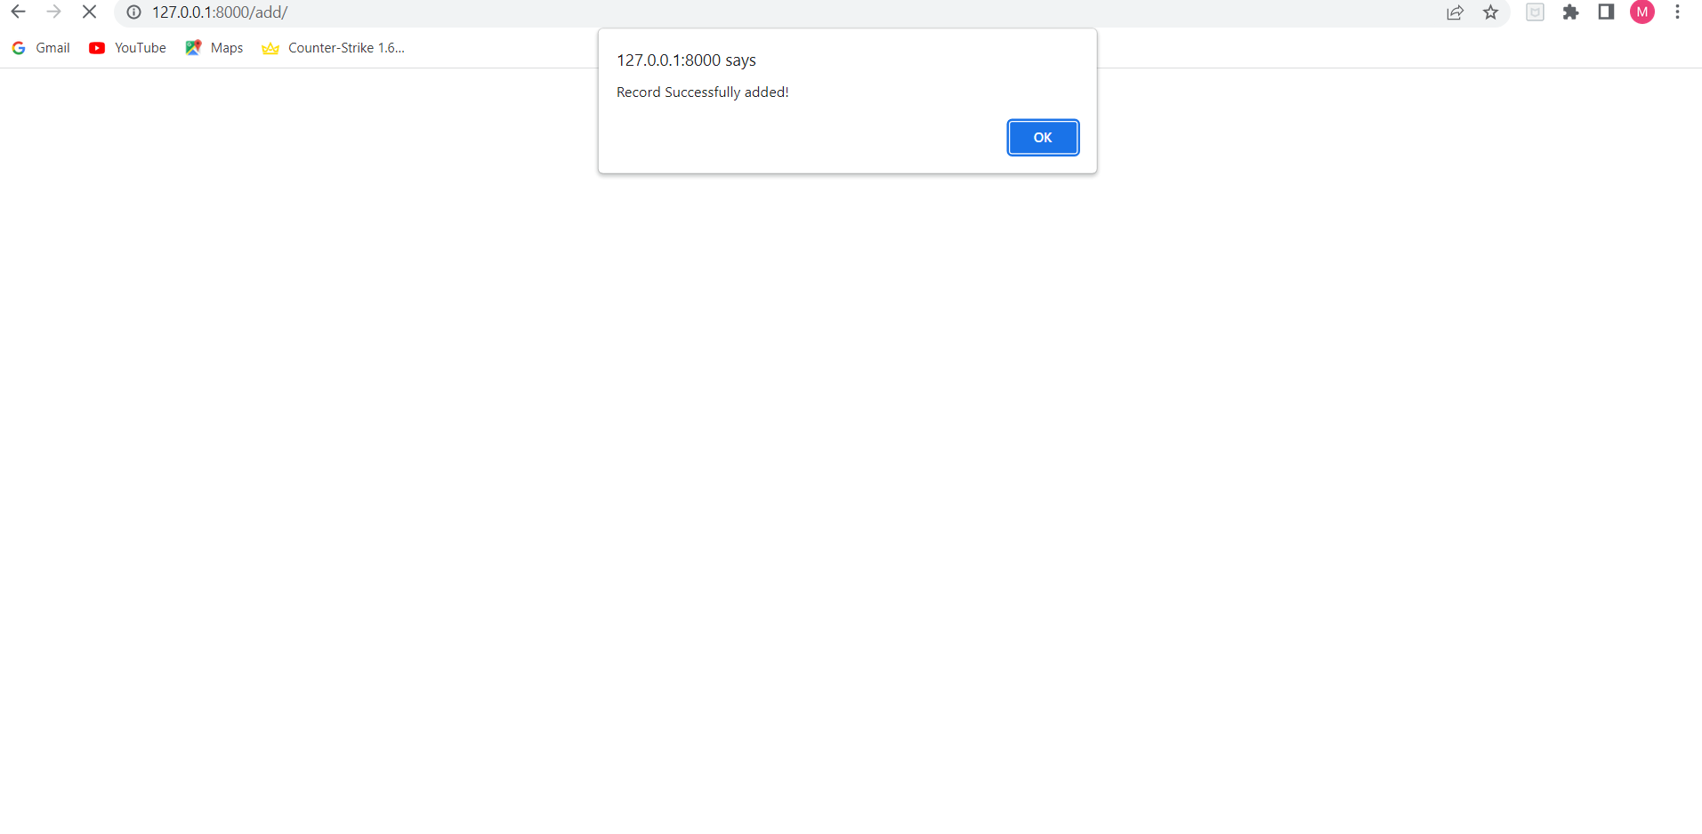

**Fig.5.5 Successful addition pop-up**

Fig.5.5 shows a successful addition message as soon as the addition of a storybook takes place.

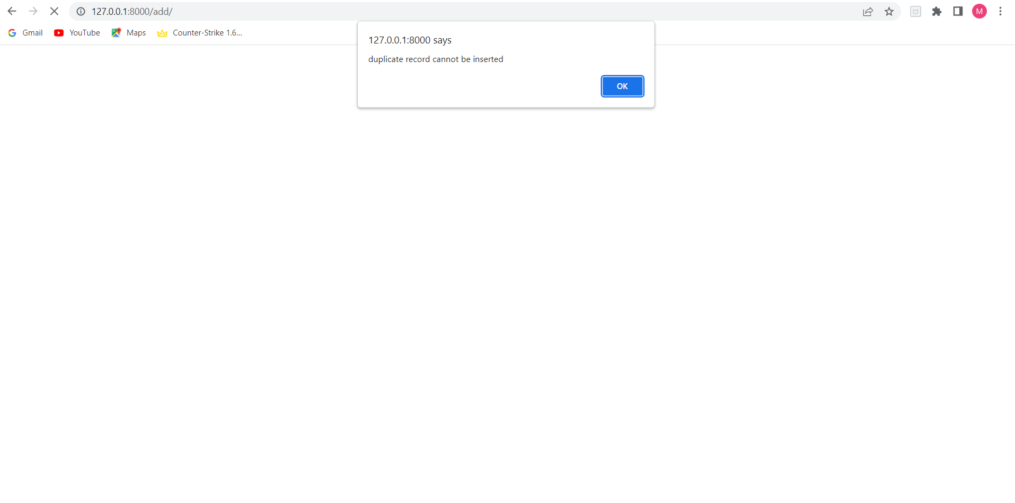

**Fig.5.6 Pop-up for entering duplicate records**

Fig.5.6 shows that an alert will be generated if the admin tries to add already existing storybook.



**Fig.5.7 Delete operation**

Fig.5.7 shows an option to delete any storybook saved previously but it can only happen from admin side.

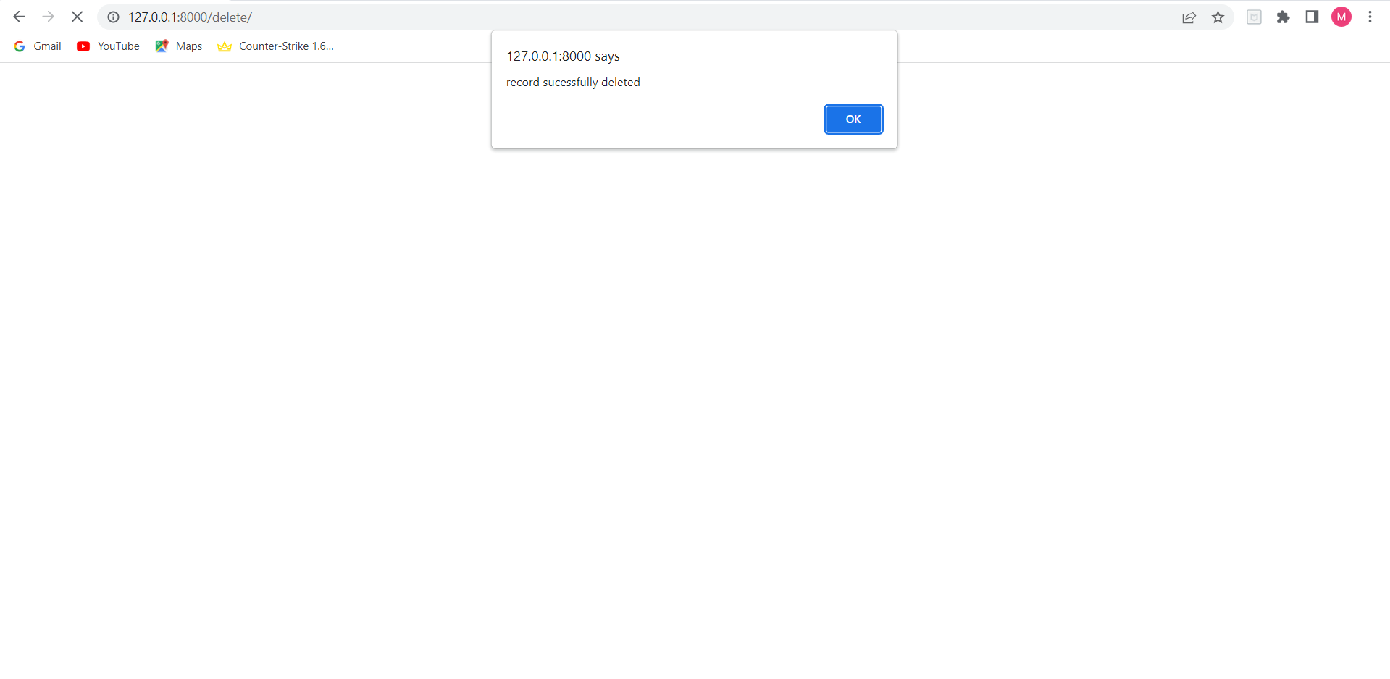

**Fig.5.8 Successful deletion**

Fig.5.8 shows a pop-up if a deletion happens successfully by admin.

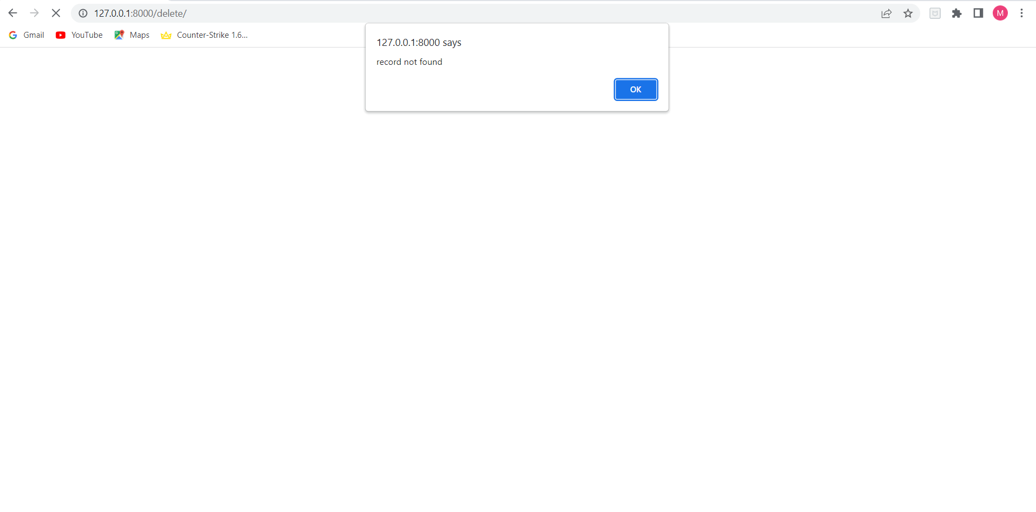

**Fig.5.9 Unsuccessful Deletion**

Fig.5.9 shows a pop-up if a deletion does not happen successfully by admin.

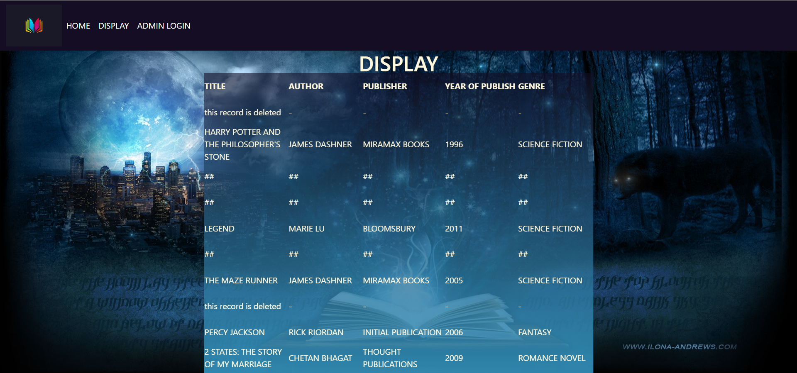

**Fig.5.10 Display the contents of the file**

Fig.5.10 shows the display page which contains all the entries, rather present or deleted entries of the records.



**Fig.5.11 Modify Operation**

Fig.5.11 shows modification option where after entering the title of the book user gets all the initial details, he has put it in and also there is a modify button from which admin can go to modify page.



**Fig.5.12 Modify operation**

Fig.5.12 shows the options to modify the previously entered records.

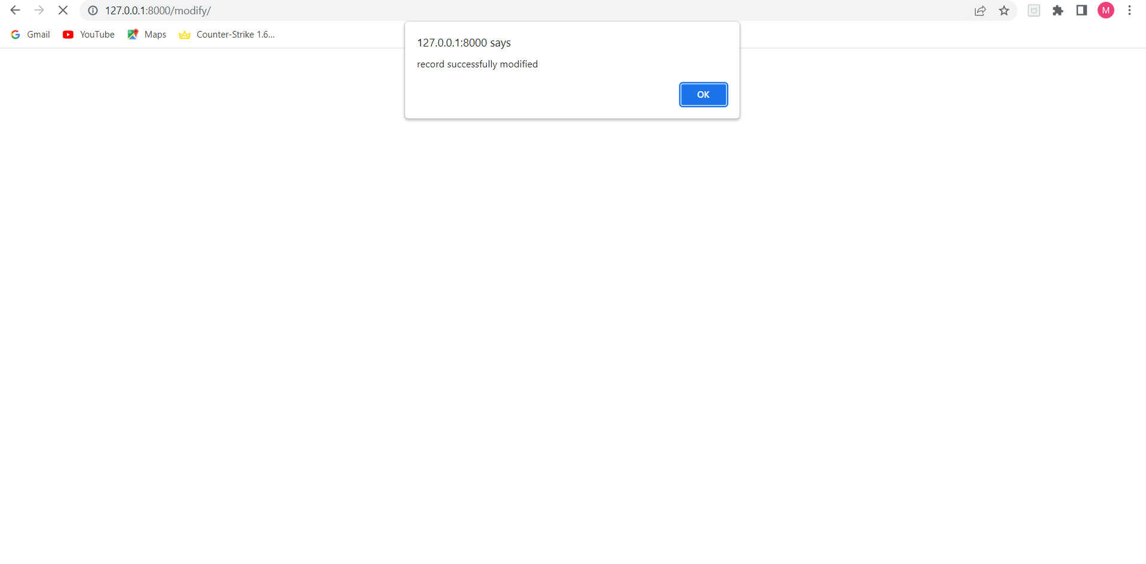

**Fig.5.13 Record Modification**

Fig.5.13 shows the pop-up after successful modification



**Fig.5.14 Modify operation**

Fig.5.14 shows no record found for a particular title entered by the admin.

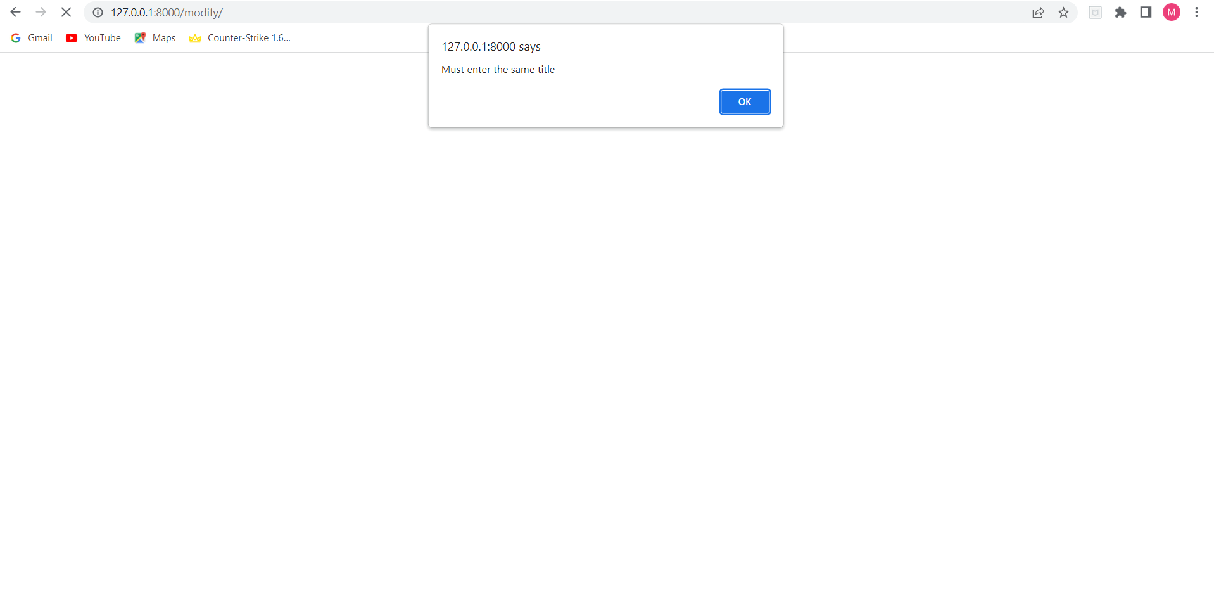

**Fig.5.15 Different title name entered by Admin**

Fig.5.15 shows that already existing record name has been entered by the admin.

**6.2 Observation about the project**

The project is observed to correctly perform the operations of requirements like search, add, view, delete, update. The details when entered by the admin for addition is appended to the data file.

The admin can view whole file details by clicking view button. The whole file is display in form of a table with field headers. The admin can delete the details by clicking on the delete. It is observed that Hashing with chained progressive overflow has many advantages like it is simple to implement.

Hash table never fills up, we can always add more elements to the chain. Less sensitive to the hash function or load factors. It is mostly used when it is unknown how many and how frequently keys may be inserted or deleted.

* 1. **Advantages of technique**
* Quick access to records in terms of selection. (If queried on the attribute that was used for hashing)
* Easy to insert, delete, or update a record.
  1. **Disadvantages of technique**
* Records are randomly stored in scattered locations. May waste a lot of space in case of small files.
* For queries that involve ranges, hash file organization is not efficient. If querying attribute is not the hashed attribute, you may need to scan the entire table for retrieval.
* Frequent update to the hashed column results in movement of data between buckets which actually affects the system performance.